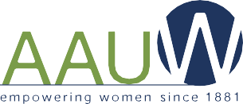
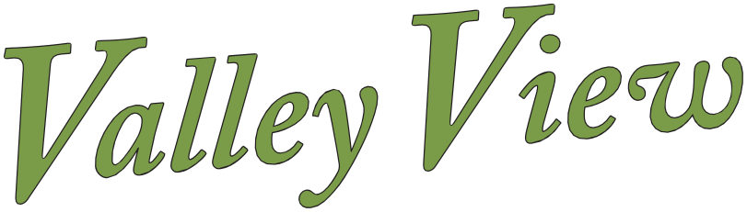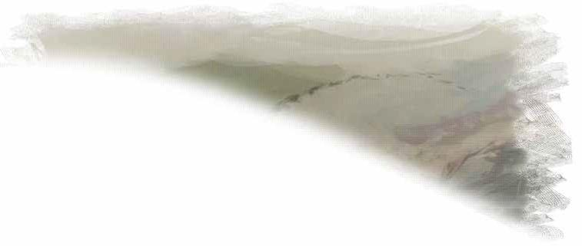
SEPTEMBER 2023
Volume 9
No. 7
Ukiah • California
ukiah-ca.aauw.net

NOTES FROM THE PRESIDENT

Hello Members,

Hope you all have managed to acclimate to our record-breaking hot summer! I am glad I
decided to take a summer break from most of my usual jobs and get to some indoor upgrades
that have been on my “to do” list. I have been enjoying the refreshing changes.

We have some updates to report. Lately Kyle and I have been working on the next yearbook in anticipation of having it ready before the Fall Dinner on Tuesday, September 19. As it
happens, we will be having our Fall Dinner as usual at the beautiful Rivino Winery. The only
change is to plan to arrive at 5:00 p.m. instead of 5:30 p.m. Fortunately, chef Earl will still be able to cater a delicious meal for us, and we will need two or three volunteers to help serve again as at the Spring Dinner meeting. Please let us know if you are available to help with that and please save the date.

Also, with regard to the Fall Dinner, please RSVP as soon as possible and include your choice of either the Salmon or the Chicken entrée. The price will be $35 again this year and inviting guests is encouraged as usual.

Katie Gibbs and Kristana are contacting a few scholarship recipients and Tech Trek gals who we hope will be able to attend the dinner. Julie Bawcom will talk about her firsthand experience working at the Tech Trek Camp. It is always inspiring to hear about personal experiences and about our mission intentions in action.

Continued on next page

SEPTEMBER 2023 Page 2

Pertinent to the September Valley View Newsletter, this year we will offer mostly digital
copies, we hope, and some printed copies when needed. Also, for your convenience, at our Fall
Dinner we will distribute printed member contact lists and copies of our by-laws to further
educate ourselves on the “proper” workings of our Ukiah Chapter.

Please return an e-mail to me or Kyle with “yes” you can receive a digital yearbook, or “a printed copy please” – sulinbell@gmail.com or mayers4ky@gmail.com as soon as possible.

We discovered an Officers & Committees Manual from 2015 in our files and have begun
to update the descriptions and responsibilities of the various positions. We plan to be able to
incorporate this information more fully this year and have an even more effective Chapter. At
the Fall Dinner we will be voting to elect some new officers, review the workings of the
Committees and hopefully inspire more members to join committees.

In addition to all our devoted Board Members, I want to take the opportunity to thank several
members who have consistently and continuously offered their help with various aspects of our
programs: Sue Mason, Vergilia Dakin, Katarzyna Rolzinski, Madelyn McCauley, Kristana Arp,
Laura Fogg, Gretel Palmerin, Camille Schraeder, Beverly Spence, Mary Ann Vilwock, Katie Gibbs and Marie Pera.

Also exciting to report: progress has been made on our intention to form a Mendocino
College AAUW Student Club, and this year’s dates for the annual Candidate Forum and for the
Women’s History Event have been determined as December 19 and March 2 respectively.

The Board has been discussing and projecting some interesting programs, so stay tuned
to e-mails, texts, and Valley View Newsletters to learn more about these developments. And
don’t forget to check in to our fabulous website to view news as it develops and to see pictures
of our beautiful Selves!

Hope to see many of you soon,

Cheerfully
Sulin

SEPTEMBER 2023 Page 3

Public Policy

AAUW California Public Policy Committee to host webinar on How to Prevent Book Banning and Curricula Censorship in California By Kathi Harper, Chair “School Board Project” Sub-Committee:

In a 2023 survey, our membership made it clear that they were alarmed by the nationwide
movement to ban books and censor curricula in K-12 schools, particularly as this censorship
denies students’ access to historically accurate information pertaining to marginalized groups.
This is perhaps unsurprising as AAUW members’ concern with access to high-quality education has been long standing.

When AAUW was founded in 1881, its stated purpose was “for practical education work, for collection and publication of statistical and other information concerning education, and in general, for the maintenance of high standards of education.” Today, AAUW California continues to support this purpose in the second pillar of our Public Policy Priorities, “Equal Access to Quality Public Education for all Students.”

Earlier this year, at the urging of the state Public Policy Committee, the state board adopted and
membership approved the addition of an important bullet point under this second pillar, “Access to diverse staff and curriculum that represents historically accurate information.” In furtherance of that goal, the Public Policy Committee has established “The School Board Project” (SBP) designed to ensure school boards up and down the state include members who are committed to “the maintenance of high standards of education” for all students–including access to diverse and historically accurate information.

Whether you are aware of problematic censorship happening in your district, you fear it may be
coming, or you just want to learn more about what AAUW California is doing, we hope you will join us virtually on September 21 at 7:00 p.m. for the presentation of “Book Banning and Curricula Censorship in California? AAUW California to the Rescue!” Kathi Harper, SBP Committee Chair, will explain the project, what we are doing, and how all AAUW California members can help. A representative from our collaborative partner, Equality California, will be in attendance to help you understand why this project is so important, and members from the League of Women Voters will be on hand to provide guidance on how to speak out effectively and civilly at school board meetings. We hope to see you there.

Registration is now open, and the link can be found on our website https://www.aauw-
ca.org/webinar-book-banning-and-curricula-censorship-in-california-aauw-california-to-the-
rescue/ Additional information about our guests and collaborators can be found at League of Women Voters—Equality California.

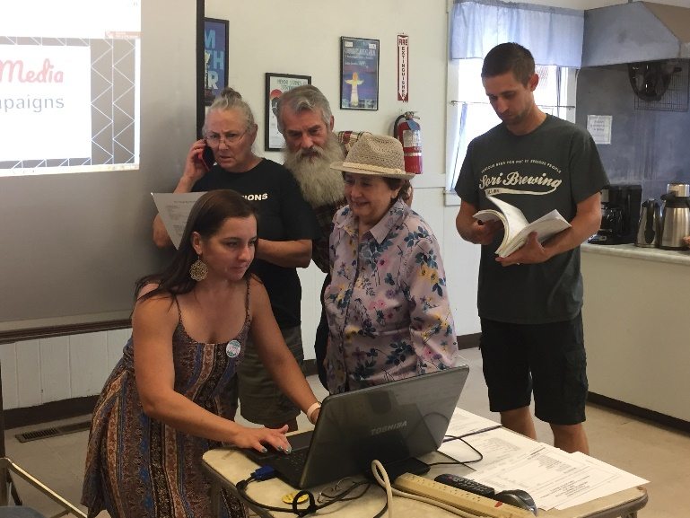
SEPTEMBER 2023 Page 5

AAUW BOOKMARKERS

September book is Demon Copperhead by Barbara Kingsolver. We will meet at Mary Ann Villwock's “new” house, 509 Jones, at 2:00 p.m. on Wednesday, September 13.

For October, we chose a non-fiction book suggested by Helen, How to Stand Up to a Dictator by Maria Ressa, from the Philippines, a 2021 Nobel prize winner. An investigative journalist, she talks about the media landscape and how it tends to favor the dictator. There are interesting You Tube articles about it. It seems particularly appropriate for the moment.

As we begin a new AAUW yearbook calendar, we would like to welcome new members to Bookmarkers. Please join us, even if you haven’t read the book.

NEXT BOARD MEETING

The next Board meeting will be on September 5 at l1:00 a.m. Anyone interested in attending needs to e-mail Sharon at sharonjeanmarshall@gmail for the location still to be determined.

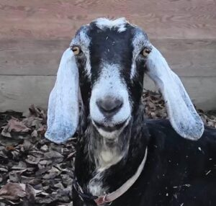

Licorice – Official Mascot 2023

