WHAT WILL BE YOUR LEGACY?
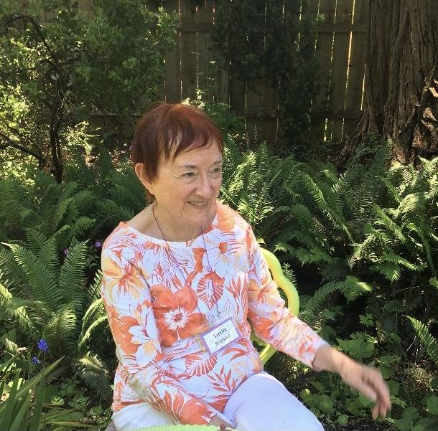
Sandy Spencer in her will left half the money from the sale of her house to the AAUW Foundation. She left the other half to University of Southern California for scholarships. Sandy wanted to follow in the footsteps of award-winning authors, scientists, scholars, changemakers and community leaders.
AAUW is providing nearly $5 million in funding to more than 260 fellows and grantees in the 2021-22 award year. These exceptional recipients will pursue academic work and lead innovative community projects to empower women and girls through a legacy left by one of
their members.

The Willits AAUW is able to fund scholarships and workshops for young women through a legacy left by one of their members. What about a local legacy to fund our work in equity for young women? Your legacy could provide funds for scholarships for needy girls and women. It could help fund Tech Trek which sends middle school students to Sonoma State for a science and technology program, Accolades which honors good citizenship of high school students, scholarships for students at Mendocino College and help fund post-graduate fellowships.

Would you consider a local legacy? Will you be next to help fund Mendocino girls and women in our quest for equity?
From Virginia (Gini) Spencer, Sandy Spencer's youngest sister
Dear AAUW members,

We all lost a good friend this year, Sandra (Sandy) Spencer, who died on April 9, 2021. Sandra Marian Spencer was born in Syracuse, NY, but in the late 1930's, her family moved to Long Beach, California, where she went to school. She received an AA degree from Long Beach City College, and went on to UCLA and graduated with a BA degree in Spanish. She then reached out and got her Master's degree in Library Science from the University of Southern Calif. (USC). Her first library job was in Santa Ana, California, but she applied for and became the Librarian for the Mendocino County School System in Ukiah, California, that she really enjoyed. She moved to Ukiah c. 1960, and while I don't know when she became a member of AAUW, but I would venture a guess that she joined as soon as she got her degrees. She also held other library positions; her last role was as a reference librarian at Mendocino College.

Sandy was a strong advocate for women's equality and enjoyed carrying out the mission and goals of AAUW, encouraging young women to get as much education as possible. She played an important leadership role for women as a mentor and leader in the Mendocino County branch of AAUW, serving in several roles: Membership, Newsletter, Vice President

Because of her belief in economic security, social equity and advocacy for women, she was most generous and gave, as part of her estate assets, funds to the AAUW Education Foundation in Washington, DC. Her legacy will benefit more women in their careers and assist in furthering their opportunities for more education. Also, as part of her bequests, AAUW will share estate funds with the University of Southern California School of Library Science. These funds are a way for her to give back and support the organizations that were most important in her life. We all thank her very much for her dedication and supportive gifts.

